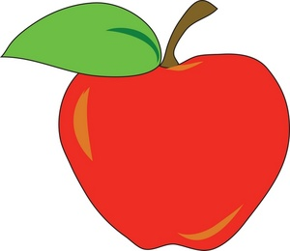

**Ingredients: (Makes 8 pint jars or 4 quart jars)**

* 12 lbs Apples (Quartered)
* 3 cups Granulated Sugar
* Water

**Directions:**

1. In kettle, combine apples with water to prevent sticking. Bring to a boil over medium-high heat. Reduce heat and boil gently, stirring occasionally, for 5 to 20 minutes, until apples are tender. Remove from heat and let cool slightly, about 5 minutes.
2. Dip apples out of kettle, and pour through juicer.
3. Add sugar.
4. Ladle hot applesauce into hot jars, leaving ½ inch headspace. Remove hair bubbles and adjust headspace, if necessary, by adding hot applesauce. Wipe rim. Center lid on jar. Screw band down until resistance is met, then increate to fingertip-tight.
5. Place jars in baskets.
6. The canning plant staff will process the applesauce for you.